# CPT_Logo_Manual.jpg An Overview of Sites and Site Collections

**Lab Time**: 60 minutes

**Lab Overview:** In this lab you will learn to navigate a Site Collection hierarchy and identify site relationships by URL and Site Content information. You will also use some of the site collection administration tools found in Site Settings to manage a site.

## Exercise 1: Identifying and Accessing a Top Level Site

In this exercise you will practice accessing a SharePoint 2010 site collection via the Top Level site and examining the hierarchy.

1. Log into your Wingtip Team Site site collection using the account **Ken Sanchez** which is the user designated as the site collection administrator.
2. Using Internet Explorer, browse to the URL of the SharePoint site collection you were provided to use when working on the hands on labs in this course.
3. When prompted to login, enter [[AD-DOMAIN]]\ken in the **User Name** field and click **OK**. Use the password specified in the *Hands-On Lab Overview* document provided in the student manual.
4. Right now you are in the top level site in the site collection. Take a note of the URL and the title of the site.
5. Select **Site Actions » Site Settings** from the ribbon.
6. Notice within the **Site Settings** page there is a **Site Collection Administration** section of links. These are only available when the site collection administrator is logged in and in the top-level site of the site collection.
7. The **Site Administration** section of links is available within all sites in the site collection.

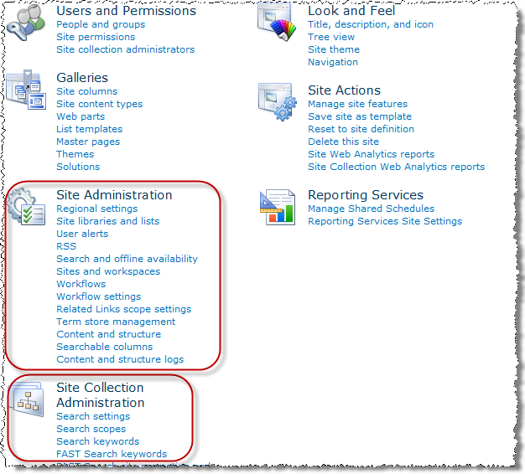

1. Navigate to a child site:
2. Click the **Products** link in the Top Navigation bar to browse to the **Products** subsite.

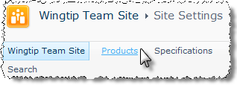

1. Take a look around the site and notice how the Top Navigation bar changed.
2. Select **Site Actions » Site Settings** from the ribbon. Notice within the **Site Settings** page there is a **Site Administration** section of links but the section for Site Collection Administration links is almost empty.

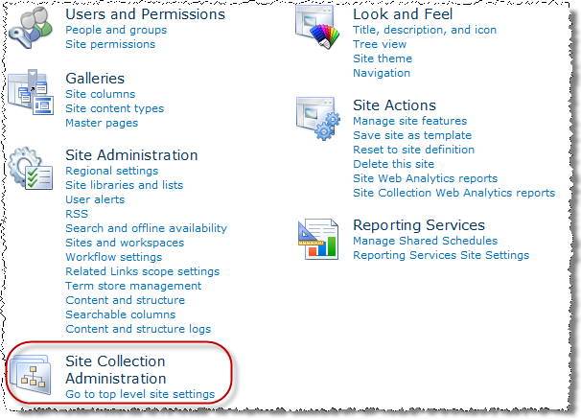

This is because you are no longer in the top-level site of the site collection.

1. Navigate to another child site:
2. Click the **Sample Subsite** link in the Top Navigation bar to browse to the **Sample Subsite** subsite that is nested within the Products site.
3. Take a look around the site and notice how the Top Navigation bar changed.
4. Select **Site Actions » Site Settings** from the ribbon. Notice within the **Site Settings** page that is very similar to the Products site’s Site Settings page.
5. Navigate back to the top level site in the site collection using the Navigation Up icon in the ribbon at the top of the page:

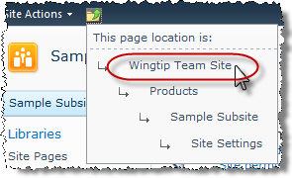

1. From your navigation in the previous steps, diagram the site collection path you found:
2. Fill in the following diagram with the appropriate site titles and URL's:
3. Identify the parent and child relationships witnessed in the path:

PARENT CHILD

\_\_\_\_\_\_\_\_\_\_\_\_\_\_\_\_\_\_\_\_\_\_\_\_\_\_\_\_\_\_\_\_\_\_\_\_\_\_\_\_\_\_\_\_\_\_\_\_\_\_\_\_\_\_\_\_\_\_\_\_\_\_\_\_\_\_\_\_\_\_\_\_\_

\_\_\_\_\_\_\_\_\_\_\_\_\_\_\_\_\_\_\_\_\_\_\_\_\_\_\_\_\_\_\_\_\_\_\_\_\_\_\_\_\_\_\_\_\_\_\_\_\_\_\_\_\_\_\_\_\_\_\_\_\_\_\_\_\_\_\_\_\_\_\_\_\_

\_\_\_\_\_\_\_\_\_\_\_\_\_\_\_\_\_\_\_\_\_\_\_\_\_\_\_\_\_\_\_\_\_\_\_\_\_\_\_\_\_\_\_\_\_\_\_\_\_\_\_\_\_\_\_\_\_\_\_\_\_\_\_\_\_\_\_\_\_\_\_\_\_

In this exercise you learned to identify and access a Site Collection's Top Level Site.

## Exercise 2: Identifying and Accessing Site Collection Children Sites

In this exercise you will practice accessing children sites within a Site Collection and witness the relationships between sites in a hierarchy.

1. Log into the Wingtip Team Site (the top level site of the Wingtip Team site collection) as Rob Walters, a member of the Site Owners group on the Wingtip Team site who has Full Control to the site.
2. Using Internet Explorer, browse to the URL of the SharePoint site collection you were provided to use when working on the hands on labs in this course.
3. When prompted to login, enter [[AD-DOMAIN]]\rob in the **User Name** field and click **OK**. Use the password specified in the *Hands-On Lab Overview* document provided in the student manual.
4. Write down the links available in the Top Navigation bar in the space provided:

\_\_\_\_\_\_\_\_\_\_\_\_\_\_\_\_\_\_\_\_\_\_\_\_\_\_\_\_\_\_\_\_\_\_\_\_

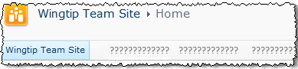

1. Navigate to the **Products** site using the site's link in the Top Navigation bar.
2. Document those sites that are children of the **Products** site in the site collection:
3. Click the **All Site Content** hyperlink at the bottom of the Quick Launch Bar to access a page that contains links and descriptions to all of the content on the site:

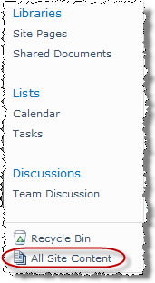

1. Scroll down the page to the **Sites and Workspaces** heading.
2. Write down the names of the **Products** site's sub sites appearing on the page:

**Hint:** There should be only one subsite.

1. Navigate to each sub site by clicking its link. Return to the **Products** site from each sub site by using the **Navigate Up** button in the upper left corner of the page before revisiting **All Site Content** before clicking the next sub site's link.

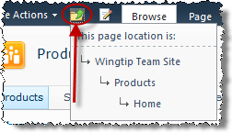

1. Once you have visited each of the **Products** site's subsites, return to the Wingtip Team site by using the **Navigate Up** button in the ribbon.
2. Navigate to the **Team Building** site using the Top Navigation Bar link.
3. Document those sites that are children of the **Team Building** site in the site collection:
4. Click the **Site Actions** hyperlink in the upper left corner of the page.
5. Click the **Site Settings** link from the resulting Site Actions drop-down menu.

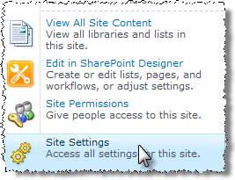

1. Click the **Sites and workspaces** link under the **Site Administration** heading:

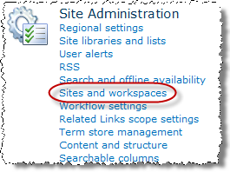

1. Document the names of the **Team Building** site's sub sites appearing on the page:

**Hint:** Is this a trick question?

1. In the following blank area, diagram the Wingtip Team site collection based on the sub sites you discovered in the previous steps.

Wingtip Team Site

1. Validate your findings for the child sites of the Wingtip Team Site (2nd tier of the site collection):
2. Click the **Site Actions** hyperlink in the upper left corner of the page.
3. Click the **Site Settings** link from the resulting Site Actions drop-down menu.
4. Click the **Sites and workspaces** link under the **Site Administration** heading.
5. Compare the subsites listed against your diagram.
6. Return to the Wingtip Team site using the **Navigate Up** button.
7. Validate your findings for the Products site (2rd tier of the site collection):
8. Navigate to the **Products** site using either the Top Navigation Bar link or the Quick Launch Bar link.
9. Click the **Site Actions** hyperlink in the upper left corner of the page.
10. Click the **Site Settings** link from the resulting Site Actions drop-down menu.
11. Click the **Sites and workspaces** link under the **Site Administration** heading.
12. Return to the Wingtip Team site using the **Navigate Up** button.
13. Validate your findings for the Sample Subsite site (3rd tier of the site collection):
14. Navigate to the **Products** site using either the Top Navigation Bar link or the Quick Launch Bar link.
15. Navigate to the **Sample Subsite** site using either the Top Navigation Bar link or the Quick Launch Bar link.
16. Click the **Site Actions** hyperlink in the upper left corner of the page.
17. Click the **Site Settings** link from the resulting Site Actions drop-down menu.
18. Click the **Sites and workspaces** link under the **Site Administration** heading.
19. Return to the Wingtip Team site using the **Navigate Up** button.
20. Validate your findings for the Team Building site (2rd tier of the site collection).
21. Navigate to the **Team Building** site using either the Top Navigation Bar link or the Quick Launch Bar link.
22. Click the **Site Actions** hyperlink in the upper left corner of the page.
23. Click the **Site Settings** link from the resulting Site Actions drop-down menu.
24. Click the **Sites and workspaces** link under the **Site Administration** heading.
25. Return to the Wingtip Team site using the **Navigate Up** button.
26. Did you miss any subsites? (You should have missed at least one.) If so, document it by adding it to your diagram and noting it as a correction to the drawing.

In this exercise you learned to identify and access children sites in a Site Collection and how they are related.

## Exercise 3: Using Site Settings

In this exercise you will utilize a few of the tools found in the Site Settings menu to manage a site collection.

1. Log into your Wingtip Team Site site collection using the account **Ken Sanchez** which is the user designated as the site collection administrator.
2. Using Internet Explorer, browse to the URL of the SharePoint site collection you were provided to use when working on the hands on labs in this course.
3. When prompted to login, enter [[AD-DOMAIN]]\ken in the **User Name** field and click **OK**. Use the password specified in the *Hands-On Lab Overview* document provided in the student manual.
4. Explore the Site Settings page as the Site Collection Administrator:
5. Click the **Site Actions** hyperlink in the upper left corner of the page.
6. Click the **Site Settings** link from the resulting Site Actions drop-down menu.
7. Note the numerous links available under the **Site Collection Administration** heading:

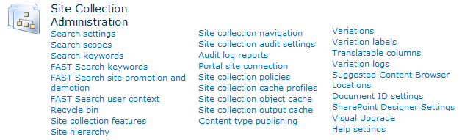

1. Document the URL of the page you are on:

\_\_\_\_\_\_\_\_\_\_\_\_\_\_\_\_\_\_\_\_\_\_\_\_\_\_\_\_\_\_\_\_\_\_\_\_\_\_\_\_\_\_\_\_\_\_\_\_\_\_\_\_\_\_\_\_\_\_\_\_\_\_\_\_\_\_\_\_\_\_\_\_\_\_\_\_\_\_\_\_

1. Login as a different user who is not the site collection administrator:
2. Authenticate into the library as Rob Walters using the **Welcome Menu** in the top right corner and select **Sign in as Different User** and enter [[AD-DOMAIN]]\rob for the user name and click **OK**.
3. Notice that the **Site Collection Administration** heading and its links disappear from the page. Why?

\_\_\_\_\_\_\_\_\_\_\_\_\_\_\_\_\_\_\_\_\_\_\_\_\_\_\_\_\_\_\_\_\_\_\_\_\_\_\_\_\_\_\_\_\_\_\_\_\_\_\_\_\_\_\_\_\_\_\_\_\_\_\_\_\_\_\_\_\_\_\_\_\_\_\_\_\_\_\_

1. Login as a different user who is the site collection administrator:
2. Authenticate into the library as Ken Sanchez using the **Welcome Menu** in the top right corner and select **Sign in as Different User** and enter [[AD-DOMAIN]]\ken for the user name and click **OK**.
3. Notice that the **Site Collection Administration** heading and its links are back.
4. Navigate to the **Manufacturing** site via the site's link in the Top Navigation Bar.
5. Click the **Site Actions** hyperlink in the upper left corner of the page.
6. Click the **Site Settings** link from the resulting Site Actions drop-down menu.
7. Note the abbreviated set of tool links available under the **Site Collection Administration** heading. Document the URL of the page you are on (is it different than before?):

\_\_\_\_\_\_\_\_\_\_\_\_\_\_\_\_\_\_\_\_\_\_\_\_\_\_\_\_\_\_\_\_\_\_\_\_\_\_\_\_\_\_\_\_\_\_\_\_\_\_\_\_\_\_\_\_\_\_\_\_\_\_\_\_\_\_\_\_\_\_\_\_\_\_\_\_\_\_\_\_\_

1. Click the **Go to top level site settings** link under the **Site Collection Administration** heading and notice the URL of the page you end up on (it should look familiar). Notice the links available under the **Site Collection Administration** heading are all back.
2. Navigate back to the **Wingtip Team Site** home page using the breadcrumb trail at the top of the page.
3. Perform basic site collection administration by examining hierarchy information:
4. Click **Site Actions** in the ribbon at the top of the page.
5. Click the **Site Settings** link from the resulting Site Actions drop-down menu.
6. Click the **Site hierarchy** link under the **Site Collection Administration** heading.

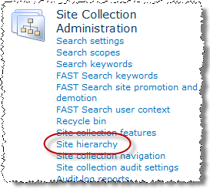

1. Examine the resulting page that lists links to every subsite and their subsites throughout the entire site collection. *This page might have come in handy in the previous exercise.*
2. Return to **Site Settings** by clicking **Site Collection Administration** in the breadcrumb trail.
3. Change site collection navigation links behavior by administering the site collection:
4. Click the **Site collection navigation** link (next link below **Site hierarchy** from previous step) under the **Site Collection Administration** heading.
5. Examine the options and note the opportunity to enable/disable the Top Navigation Bar and Quick Launch Bar as well as enable/disable security trimming and audience targeting. Also note that all of these features are enable by default.
6. In the **Navigation Enabled** section, **clear the checkbox** for **Enable navigation** to disable the Top Navigation Bar and Quick Launch Bar throughout the site collection. Click **OK** to save the setting.
7. Return to the **Wingtip Team Site** via the breadcrumb trail. Notice that the only link in the Top Navigation Bar is for the Wingtip Team Site itself (subsites no longer appear) and notice that the Quick Launch Bar links for content are gone (although the Recycle Bin and All Site Content links are still available).
8. Click the **All Site Content** hyperlink on the left side of the page.
9. Scroll down the page to the **Sites and Workspaces** heading and click the link to the **Manufacturing** site in the site collection.
10. Notice that the only link in the Top Navigation Bar is for the **Manufacturing** site itself and that the Quick Launch Bar links (with the exception of Recycle Bin and All Site Content) are gone as well.
11. Click the **Site Actions** hyperlink in the upper left corner of the page.
12. Click the **Site Settings** link from the resulting Site Actions drop-down menu.
13. Click the **Go to top level site settings** link under the **Site Collection Administration** heading.
14. On the Wingtip Team Site top level site's **Site Settings** page, click the **Site collection navigation** link under the **Site Collection Administration** heading.
15. In the **Navigation Enabled** section, **check the checkbox** entitled **Enable navigation** to re-enable the Top Navigation Bar and Quick Launch Bar throughout the site collection. Click **OK** to save the setting.
16. Return to the Wingtip Team Site via the breadcrumb trail. Notice that the Top Navigation Bar links and the Quick Launch Bar links are back.

In this exercise you used some of the tools in checking out the hierarchy of the Wingtip Team Site site collection.

## Exercise 4: Working with SharePoint Auditing

In this exercise you will setup and examine the auditing capabilities in SharePoint 2010.

1. Log into your Wingtip Team Site site collection using the account **Ken Sanchez** which is the user designated as the site collection administrator.
2. Using Internet Explorer, browse to the URL of the SharePoint site collection you were provided to use when working on the hands on labs in this course.
3. When prompted to login, enter [[AD-DOMAIN]]\ken in the **User Name** field and click **OK**. Use the password specified in the *Hands-On Lab Overview* document provided in the student manual.
4. Set up site collection auditing by administering the site collection:
5. Click the **Site Actions** hyperlink in the upper left corner of the page.
6. Click the **Site Settings** link from the resulting Site Actions drop-down menu.
7. Click the **Site collection audit settings** link under the **Site Collection Administration** heading.

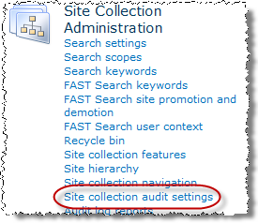

1. Examine the resulting page that allows you to limit audit log size, save the log before trimming, and select the events that will be logged throughout the entire site collection. Check the option **Opening or downloading documents…** and **Editing Items**. Then click **OK**.

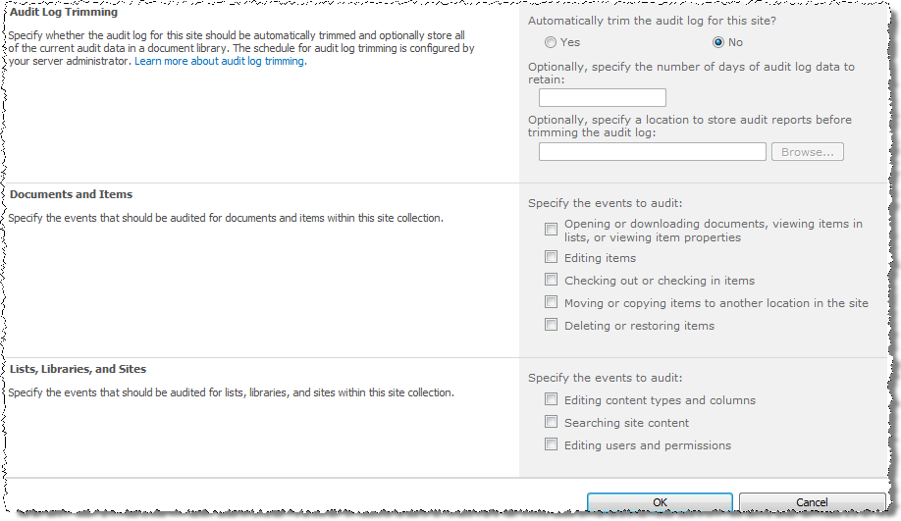

1. Return to the **Wingtip Team Site** via the breadcrumb trail.
2. Create sample content, view and edit existing content to trigger audit entries:
3. Using Microsoft Word, create a new file WingtipHistory.docx on your workstation, add some content to it and save it to the desktop.
4. Upload the WingtipHistory.docx file to the **Shared Documents** library using the **Upload Document** button in the **Library Tools » Documents** tab in the ribbon.
5. Read the default **Announcement** item in the **Announcements** list (use the **All Site Content** link in the Quick Launch bar to get to the Announcements list).
6. Delete the default **Announcement** item in the **Announcements** list.
7. Generate a content modification audit report:
8. Click the **Site Actions** hyperlink in the upper left corner of the page.
9. Click the **Site Settings** link from the resulting Site Actions drop-down menu.
10. Click the **Audit log reports** link under the **Site Collection Administration** heading.
11. Click the name of the first report, **Content modifications**, to configure the report.

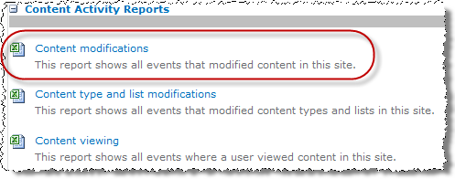

1. In the **File Location** section, click the **Browse** button and select the **Shared Documents** library under **Wingtip Team Site** then click **OK** to return to the **File Location** section. Verify that the relative path **/Shared Documents** now appears in the **Save location:** field.

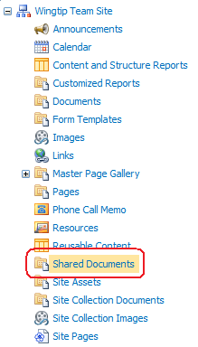

1. Click **OK** to save the report destination information and begin generating the report.
2. Once the report has been generated and saved to the Shared Documents library, click **OK** to the success pop-up message.

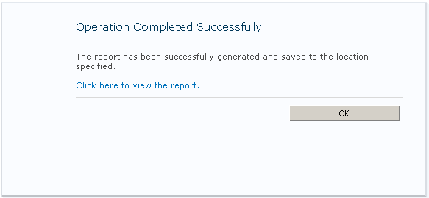

1. Now back at **Site Settings**, click the **Audit log reports** link under the **Site Collection Administration** heading.
2. Click the **Content viewing** report name to configure the report.

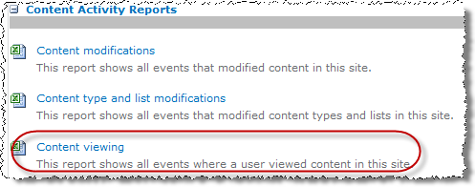

1. Use your newly acquired skills to **Browse** and select the **Shared Documents** library again, then click **OK** three times to configure the report, generate the report, and accept the success message.
2. Return to the **Wingtip Team Site** via the breadcrumb trail.
3. Open the **Content modifications** report from the **Shared Documents** library's Web Part on the home page of the Wingtip Team Site.
4. Once open in Excel in Read-Only mode, notice that the report has two spreadsheets in the workbook: **Audit Data** and **Report Data**. Examine both worksheets of information.
5. How many items were updated in the Shared Documents library? \_\_\_\_\_\_\_\_\_\_\_\_\_
6. Close the report workbook (if prompted, choose Don't Save) and exit Excel.
7. Open the **Content viewing** report from the **Shared Documents** library's Web Part on the home page of the Wingtip Team Site.
8. Once open in Excel in Read-Only mode, notice that the report has two spreadsheets in the workbook: **Audit Data** and **Report Data**. Examine both worksheets of information.
9. Notice that even though you only viewed one announcement item from the Announcements list there are several viewings listed in the report. What other resources were viewed from the site?

\_\_\_\_\_\_\_\_\_\_\_\_\_\_\_\_\_\_\_\_\_\_\_\_\_\_\_\_\_\_\_\_\_\_\_\_\_\_\_\_\_\_\_\_\_\_\_\_\_\_\_\_\_\_\_\_\_\_\_\_\_\_\_\_\_\_\_\_\_\_\_\_\_\_\_\_\_\_\_\_\_

\_\_\_\_\_\_\_\_\_\_\_\_\_\_\_\_\_\_\_\_\_\_\_\_\_\_\_\_\_\_\_\_\_\_\_\_\_\_\_\_\_\_\_\_\_\_\_\_\_\_\_\_\_\_\_\_\_\_\_\_\_\_\_\_\_\_\_\_\_\_\_\_\_\_\_\_\_\_\_\_\_

1. Close the report workbook (if prompted, choose Don't Save) and exit Excel.

In this exercise you setup and examined the auditing capabilities in SharePoint 2010.